**STANFORD HISTORY EDUCATION GROUP**

READING LIKE A **HIST** Name

**Why did Texans declare independence from Mexico in 1836?**

**Who wrote it? According to this document, why did Texans decide Do you trust the perspective of this document? Why**

1. Name ? **to declare independence in** Provide a quote to **or not?**

2. Mexican or American? support your claim.

3. Year?

**Document**

**A**

**Document**

**B**

**C**

**Document**

**D**

**Final Conclusion:** Based on all four documents, do you think that the Texans were justified in declaring independence?

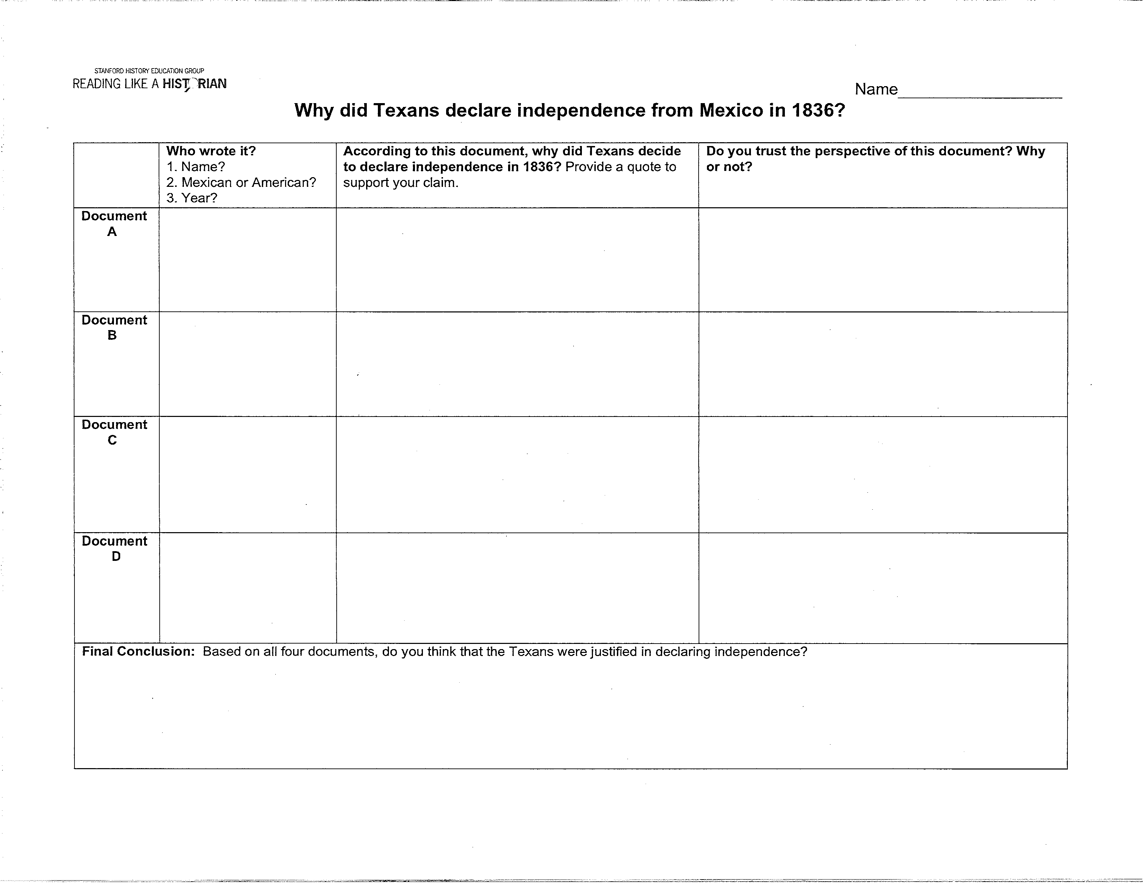

**STANFORD HISTORY GROUP**

READING LIKE A

**Document A (Modified)**

**Texas Declaration of Independence (March [Adapted]**

When a government has ceased to protect the lives, liberty and property of the people .. . it is the right of the people to abolish such government, and create another one that will secure their future welfare and happiness.

General Santa Anna, has overturned the constitution of his country, and now offers us the cruel option either to abandon our homes, or submit to the most intolerable of all tyranny.

The Mexican government has failed to establish any public system of education...

It denies us the right of worshipping the Almighty as we want to...

It has demanded that we give up our arms, which are essential to our defense...

It has invaded our country both by sea and by land, with intent to lay waste our territory, and drive us from our homes...

It has encouraged the merciless Indians to massacre the inhabitants of our defenseless frontiers....

We, therefore, do hereby resolve and declare, that our political connection with the Mexican nation has forever ended, and that the people of Texas do now constitute a free, Sovereign, and independent republic...

Texas Independence

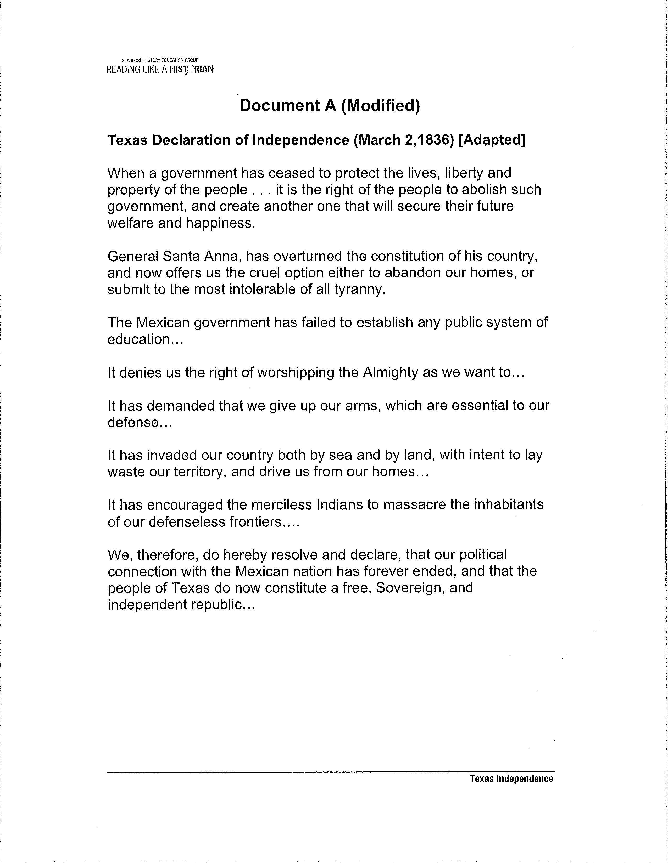

**STANFORD HISTORY EDUCATION GROUP**

READING LIKE A

**Document B (Modified)**

We cannot trust the Anglo-American colonists because they are continually demonstrating that they refuse to follow our laws, unless it is convenient for them. We will have many problems if we do not

stop their disrespectful behavior by stationing soldiers and a Mexican judge in each settlement. They have been using their own colonists as judges and practicing their own laws, forgetting that they swore to obey the laws of Mexico.

*Source: The letter above was written by Rafael Manchola, a Tejano*

*(Mexican living in Texas). He wrote this letter about the Anglo-Americans in to a military commander.*

**Document C (Modified)**

Colonel Juan

Alamo Defenders' Burial Speech, April 4,

Companions in Arms!! These remains which we have the honor of carrying on our shoulders are those of the brave heroes who died in the Alamo. Yes, my friends, they preferred to die a thousand times rather than submit themselves to the tyrant's yoke. Yes, soldiers and fellow citizens, these are the worthy beings who, by the twists of fate, delivered their bodies to the ferocity of their enemies. invite you to declare to the entire world, "Texas shall be free and independent or we shall perish in glorious combat."

*Source: Colonel Juan Seguin's Alamo Defenders' Burial Speech, April 4,*

*Seguin was a Mexican who supported the Texas Revolution and fought with the American settlers against General Santa Anna. This speech was given at the burial of the men who died at the Alamo.*

Texas Independence

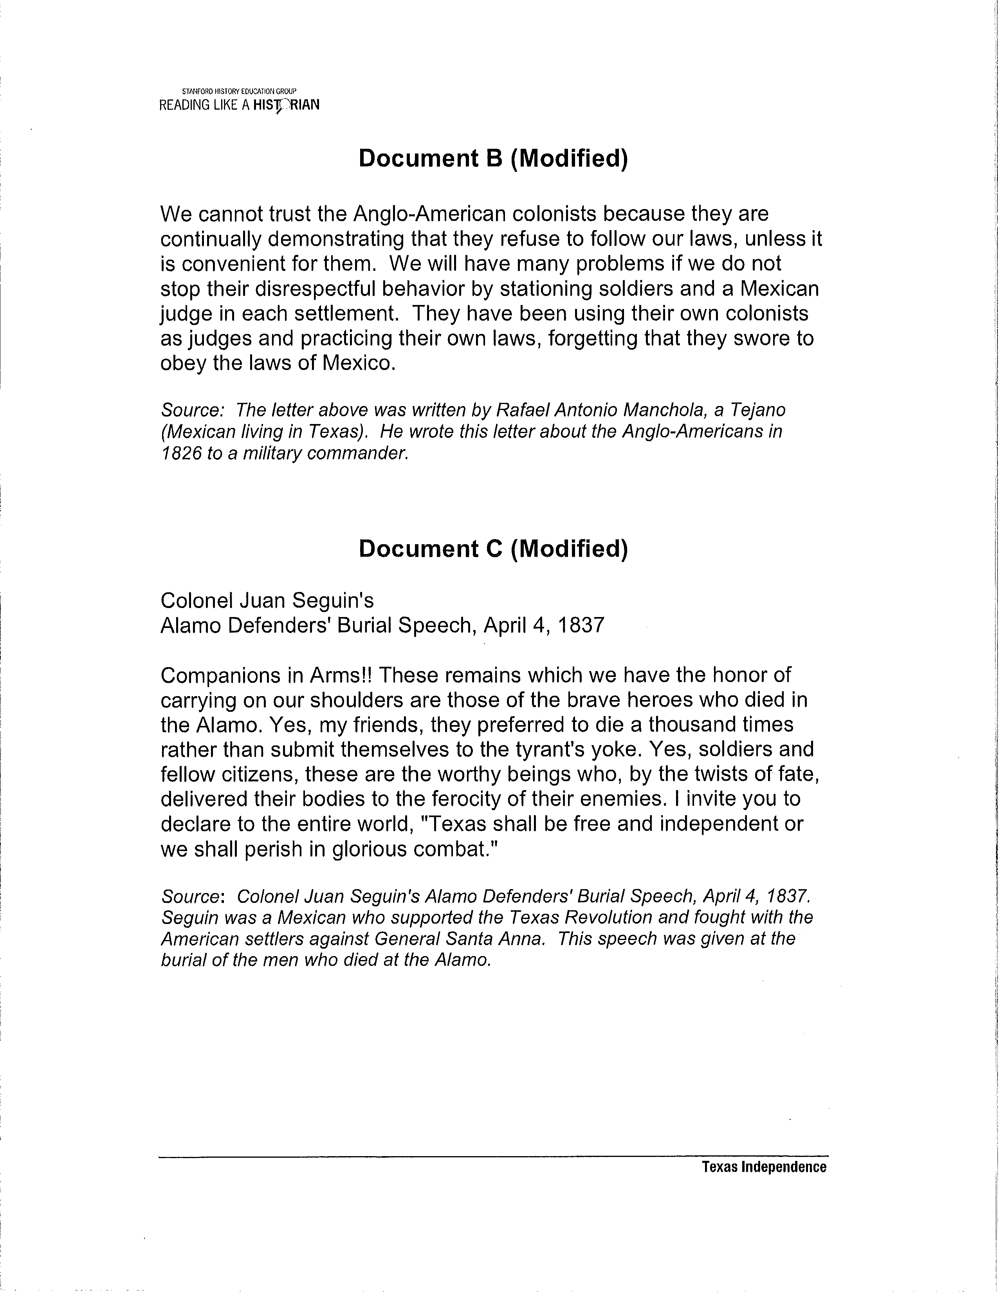

**STANFORD HISTORY GROUP**

READING LIKE A

**Document D (Modified)**

We have been asked to believe that the inhabitants of Texas have been fighting to maintain the sacred principles of Liberty, and the natural, inalienable Rights of their motives have been exactly the opposite. The immediate cause and main goal of this by the slaveholders of this country, (with land speculators and slave traders)---has been to grab the large and valuable territory of Texas from the Mexican Republic, in order to establish the SYSTE M OF SLAVERY; to open a vast and profitable SLAVEMARKET; and, ultimately, to annex it to the United States.

*Source: Benjamin Lundy became active in the movement in the*

*He organized abolitionist societies, lectured extensively, and contributed*

*to many abolitionist publications. He wrote this pamphlet called The War in Texas in Lundy argued that the Texas revolution was a slaveholders' plot to take Texas from Mexico and to add slave territory to the United States.*

Texas Independence

