Name

Holocaust Document Based Question

This question is based on the accompanying documents (1–?). The question is designed to test your ability to work with historical documents. Some of the documents have been edited for the purposes of the question. As you analyze the documents, take into account both the source of each document and any point of view that may be presented in the document.

Historical Context: Genocide Holocaust
The rise of the Nazi Party from 1933-1945 had a profound impact on the lives of many people throughout Europe. Innocent people including over a million children suffered at the hands of the Nazis. Throughout the course of the Holocaust between five and six million Jews were killed.

Task: Using information from the documents and your knowledge of global history, answer the questions that follow each document in Part A. Your answers to the questions will help you write the Part B essay in which you will be asked to:

Examine the documents to how the Nazis changed life for Jews living in Europe politically, economically and socially?
How were Jews treated in Nazi Germany?
How did Nazi’s implement their “Final Solution”
Part A

Short-Answer Questions

Directions: Analyze the documents and answer the questions that follow each document in the space provided. Your answers to the questions will help you write the essay.

Document 1

Message from SS-Grupenführer Heydrich to all State Police Main Offices and Field Offices, November 10 1938

Regards: Measures against Jews

a) Only such measures may be taken which do not jeopardize German life or property (for instance, burning of synagogues only if there is no danger of fires for the neighborhoods).
b) Business establishments and homes of Jews may be destroyed but not looted. The police have been instructed to supervise the execution of these directives and to arrest looters.
c) In Business streets special care is to be taken that non-Jewish establishments will be safeguarded at all cost against damage.

As soon as the events of this night permit the use of the designated officers, as many Jews, particularly wealthy ones, as the local jails will hold, are to be arrested in all districts. Initially only healthy male Jews, not too old, are to be arrested. After the arrests have been carried out the appropriate concentration camp is to be contacted immediately with a view to a quick transfer of the Jews to the camps
- Nazi Conspiracy and Aggression - Washington, U.S Govt. Print. Off., 1946, Vol. III, p. 545-547.

1) How would this Message from SS-Grupenführer Heydrich change life for the Jews?

1a) Were German citizens treated the same way as the Jews were?

Smuggling began at the very moment that the Jewish area of residence was established; its inhabitants were forced to live on 180 grams of bread a day, 220 grams of sugar a month, 1 kg. of jam and 1 kg. of honey, etc. It was calculated that the officially supplied rations did not cover even
10 percent of the normal requirements. If one had wanted really to restrict oneself to the official rations then the entire population of the ghetto would have had to die of hunger in a very short time.... The German authorities did everything to seal off the ghetto hermetically and not to allow in a single gram of food. A wall was put up around the ghetto on all sides that did not leave a single millimeter of open space.... They fixed barbed wire and broken glass to the top of the wall.
- Life in the Warsaw Ghetto, Emanuel Ringelblum quoted in Yad Vashem Documents on the Holocaust, pp 228-229:

2) Explain why many Jews living in the Warsaw Ghetto starved to death?

Document 3

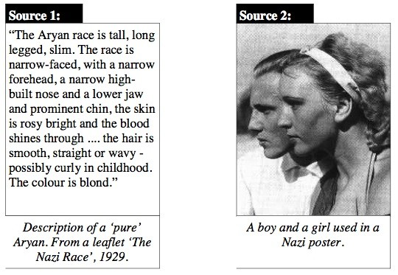

3) Describes Hitler’s “Master Race” using the two sources above

If my memory serves me right, about thirty to forty women were gassed in one gas chamber. The Jewish women were forced to undress in an open place close to the gas chamber, and were driven into the gas chamber by the above mentioned SS members and the Ukrainian auxiliaries. when the women were shut up in the gas chamber I and Bolender set the motor in motion. The motor functioned first in neutral. Both of us stood by the motor and switched from "Neutral" (Freiauspuff) to "Cell" (Zelle), so that the gas was conveyed to the chamber. At the suggestion of the chemist, I fixed the motor on a definite speed so that it was unnecessary henceforth to press on the gas. About ten minutes later the thirty to forty women were dead.
- From the testimony of SS-Unterscharfuehrer Wilhelm Bahr in his trial at Hamburg.
Quoted in "Truth Prevails"

4) Based on the testimony of this SS officer, what happened to the women prisoners of this
Concentration camp?

Document 5

Nazi boycott of Jewish businesses

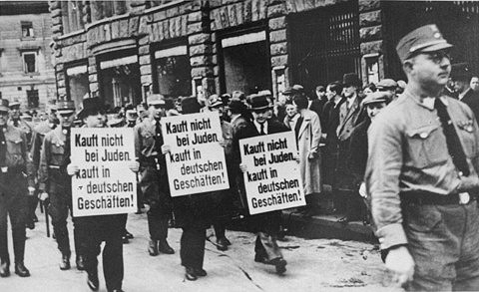

5) How would the boycott of the businesses change the economic livelihood of the Jews & help the Nazis’?

If I am ever in power the destruction of the Jews will be my first and most important job. As soon as I have the power I shall have gallows after gallows erected. Then Jews will be hanged one after another and will stay hanging until they stink.
- Letter from Hitler to Josef Hell, 1922

6) Why do many consider Hitler to be a racist?

Document 7

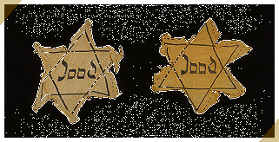In May 1942, all Jews aged six and older are required to wear a yellow Star of David on their clothes to set them apart from non-Jews.

7) What was the purpose of Identification badges?

Document 8

Anne Frank attends the local Montessori school, but after summer recess in 1941, she is not allowed to attend school with non-Jews.

8) How did education change for Anne Frank and other children after the Nazis came to power?

