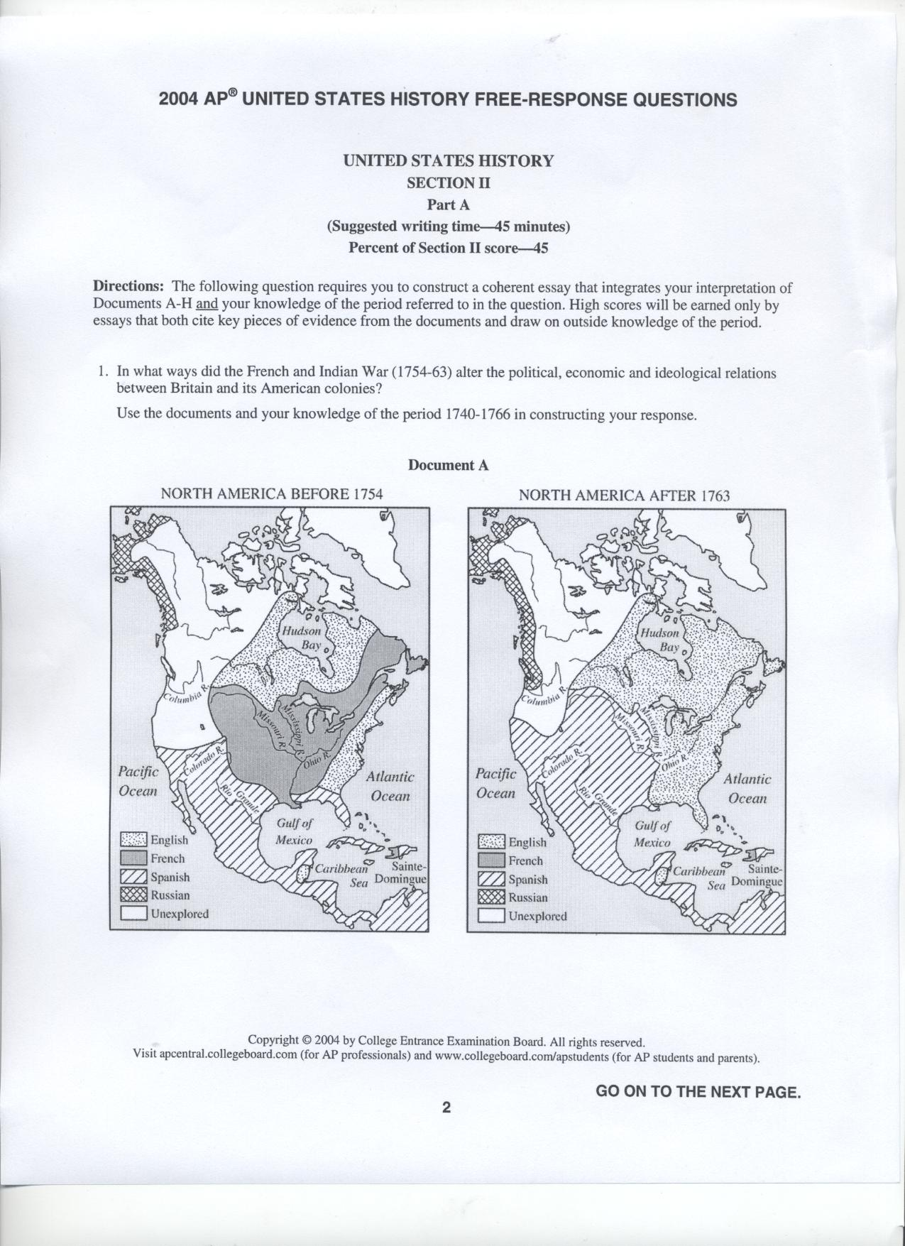
Task: In what ways did the French and Indian War (1754-1763) alter the political, economic and ideological relations between Britain and its American colonies?

Directions: As you look at the document, complete the following thoughts.
Document A:
- There was a significant shift of colonial power in North America…

- The expanded territorial claims for Britain led to…

- The French were now…

- The impending westward expansion would lead to…

Outside Information that relates to the information in the document and helps explain the cause and effect that developed into the altering of political, economic and ideological relations between Britain and its American colonies

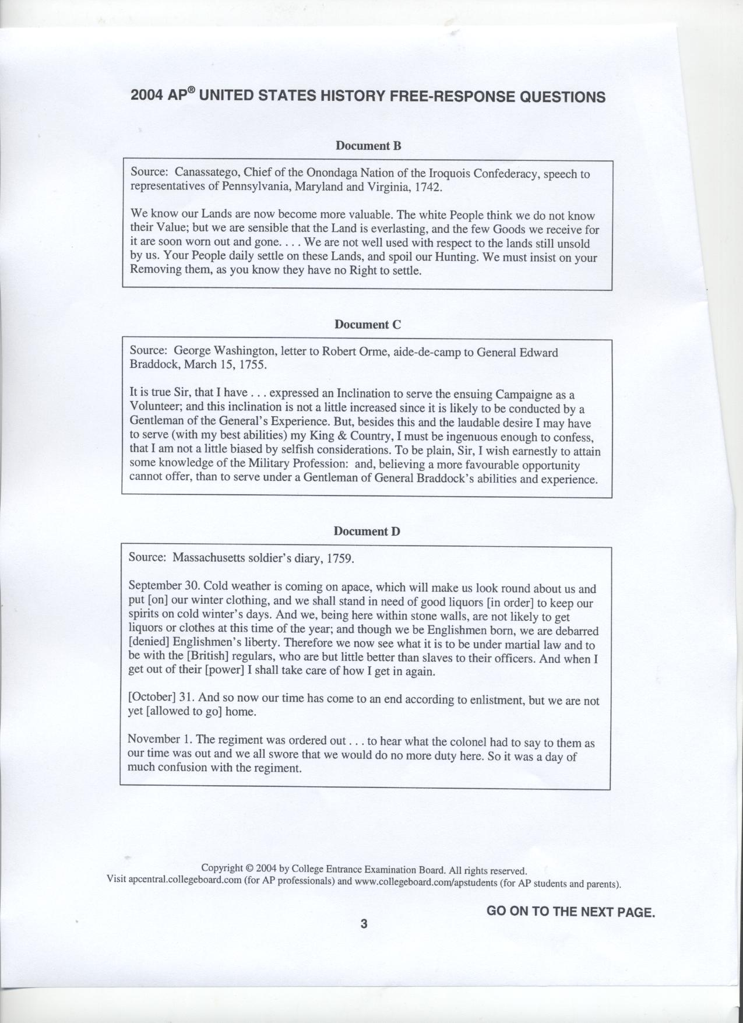
Task: In what ways did the French and Indian War (1754-1763) alter the political, economic and ideological relations between Britain and its American colonies?

Directions: As you look at the document, complete the following thoughts.
Document B:
- The relationship between the Iroquois Confederacy & the British was…

- Earlier land treaties were…

- The Indian way of life was…

- White settlers…

- The Iroquois hoped to prevent…
Outside Information that relates to the information in the document and helps explain the cause and effect that developed into the altering of political, economic and ideological relations between Britain and its American colonies

Task: In what ways did the French and Indian War (1754-1763) alter the political, economic and ideological relations between Britain and its American colonies?

Directions: As you look at the document, complete the following thoughts.
Document C:
- It is fair to say George Washington…

- Washington shows loyalty to…

- Washington showed respect for…

- Colonial leadership…

Outside Information that relates to the information in the document and helps explain the cause and effect that developed into the altering of political, economic and ideological relations between Britain and its American colonies

Task: In what ways did the French and Indian War (1754-1763) alter the political, economic and ideological relations between Britain and its American colonies?
Directions: As you look at the document, complete the following thoughts.
Document D:
- Colonial militiaman was enlisted to serve…

- This man begins to question…

- British authority perceived to threaten…

- He has a diminishing respect for…

- Soldiers were treated…

- The war experience had the effect of creating _________ b/w British troops and colonists
Outside Information that relates to the information in the document and helps explain the cause and effect that developed into the altering of political, economic and ideological relations between Britain and its American colonies

Task: In what ways did the French and Indian War (1754-1763) alter the political, economic and ideological relations between Britain and its American colonies?
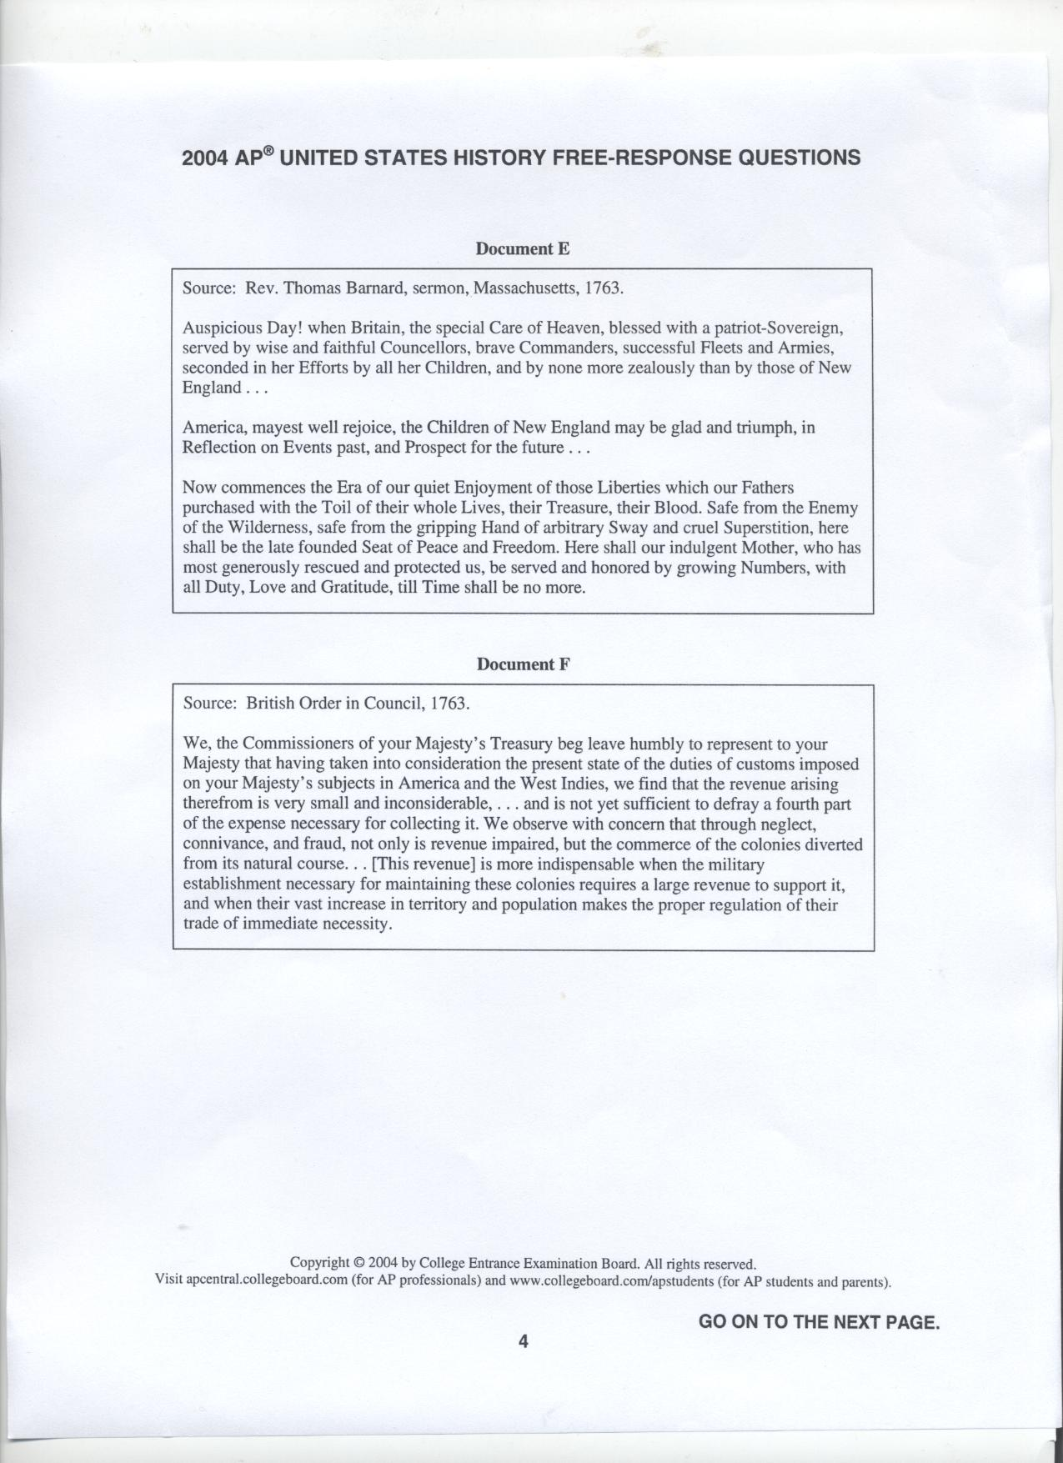
Directions: As you look at the document, complete the following thoughts.
Document E:
- The year 1763 signifies…

- The tone is celebratory of….

- There is no sign of animosity…

- He recognizes the colonists’ role in..

- Overall this document’s tone can be described as…
Outside Information that relates to the information in the document and helps explain the cause and effect that developed into the altering of political, economic and ideological relations between Britain and its American colonies

Task: In what ways did the French and Indian War (1754-1763) alter the political, economic and ideological relations between Britain and its American colonies?
Directions: As you look at the document, complete the following thoughts.
Document F:
- The future of salutary neglect was…

- The future role of mercantilism was…

- Colonies needed to assume a greater share of the…

- Increased British debt required greater…

- Colonial governments in the future will have…(in terms of control)

- The foreshadowing allusion is to a larger military presence…
Outside Information that relates to the information in the document and helps explain the cause and effect that developed into the altering of political, economic and ideological relations between Britain and its American colonies

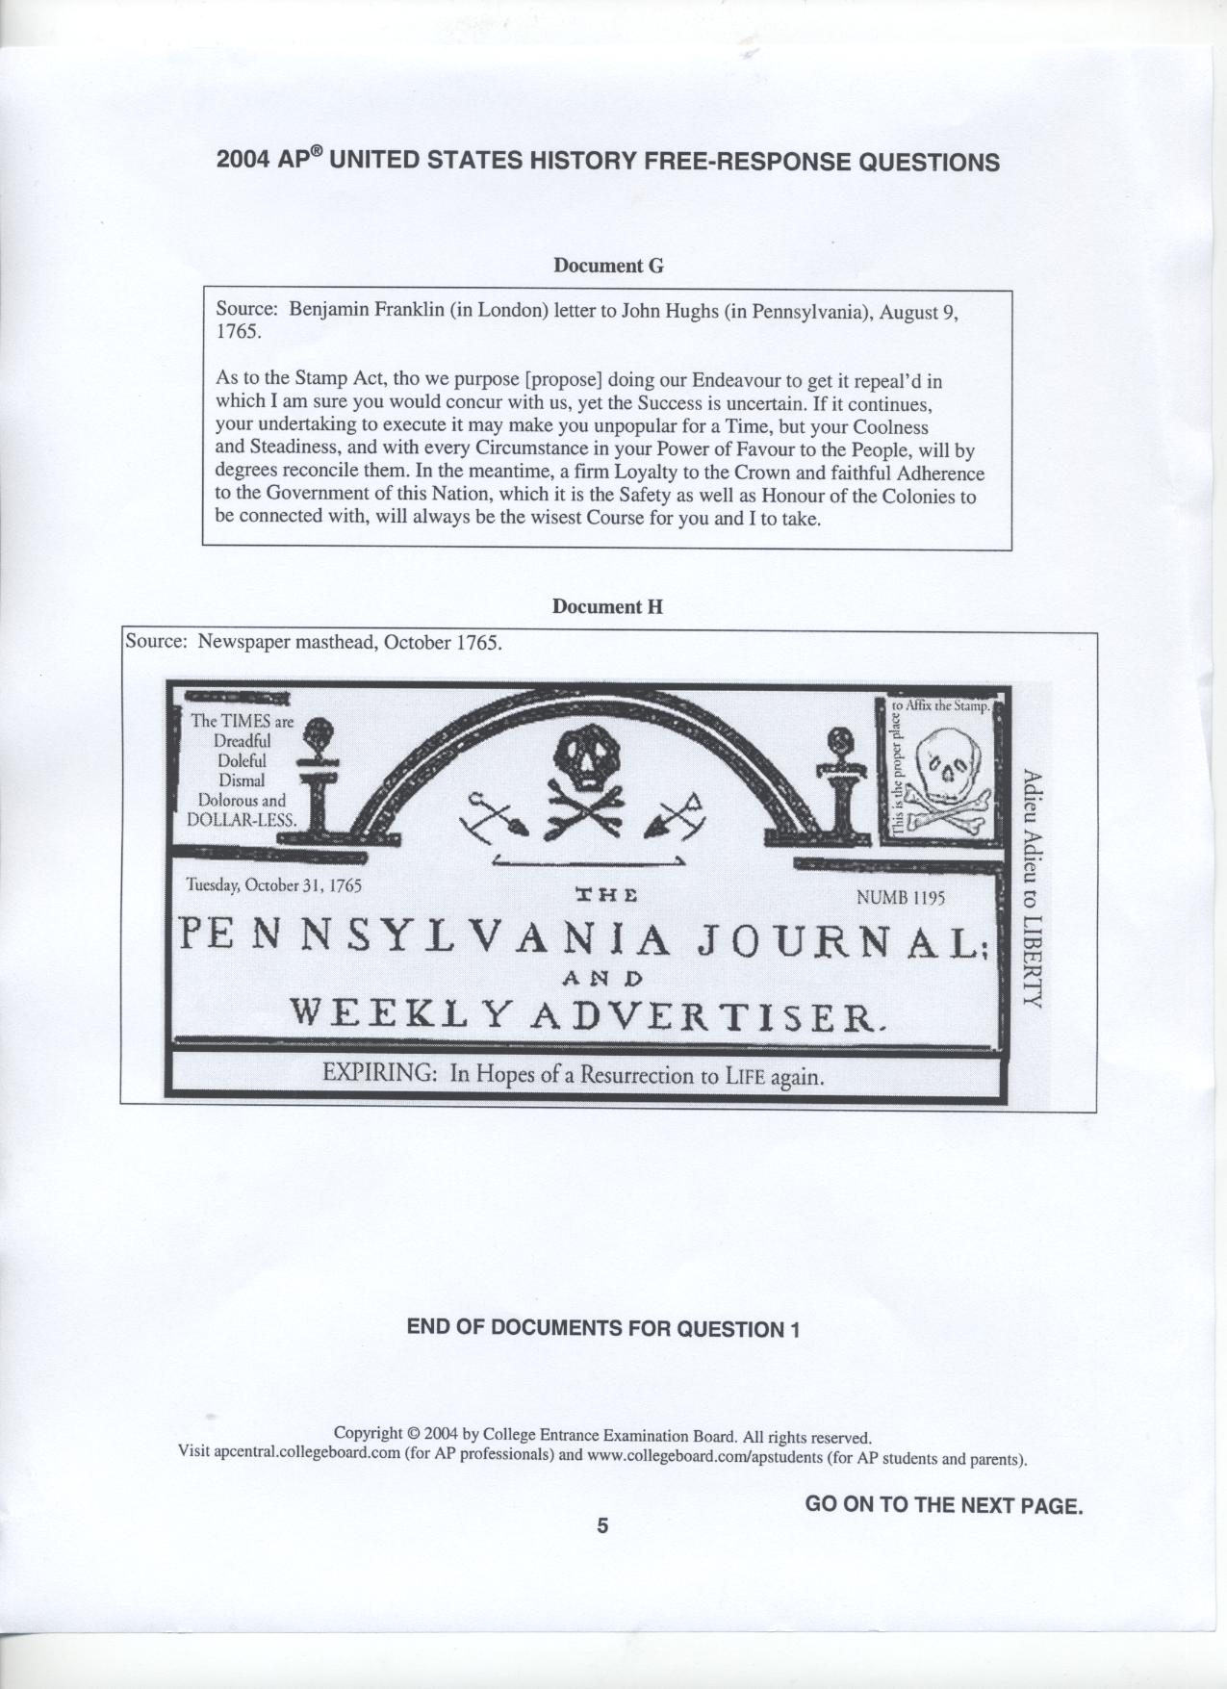
Task: In what ways did the French and Indian War (1754-1763) alter the political, economic and ideological relations between Britain and its American colonies?
Directions: As you look at the document, complete the following thoughts.
Document G:
- Franklin’s goal with this letter is to…

- Franklin alerts British officials about colonial opposition…

- Franklin favors maintaining law and order to prevent…

- Franklin fears violent opposition from…

Outside Information that relates to the information in the document and helps explain the cause and effect that developed into the altering of political, economic and ideological relations between Britain and its American colonies

Task: In what ways did the French and Indian War (1754-1763) alter the political, economic and ideological relations between Britain and its American colonies?

Directions: As you look at the document, complete the following thoughts.
Document H:
- The tombstone masthead represents…

- This ad encourages colonial opposition to…

- This ad bemoans the loss of…

Outside Information that relates to the information in the document and helps explain the cause and effect that developed into the altering of political, economic and ideological relations between Britain and its American colonies

