Personal Coat of Arms

In the Middle Ages, individuals were identified by their Coat of Arms. As they were used on the battlefield to identify a person’s friends and foes, they were often in the shape of a shield. The symbols used on coats of arms were chosen carefully to represent an individual or an entire family. The study of the symbols, colors and patterns used in Coats of Arms is known as heraldry.

Design your own Coat of Arms

Create your own COAT of ARMS based on your hobbies, personality, character and family. Read through the list of colors, animals and symbols shown below—which represent you?
Can you think of more animals or symbols that you could use on your Coat of Arms?

Include the following information on your own Coat of Arms.
1. A symbol / picture to represent an important place.
2. A symbol / picture to represent a hobby / activity
3. An animal that represents you
4. Any other symbol or picture that represents you.
5. Include a Personal Motto (words or a phrase that represent you) at the top

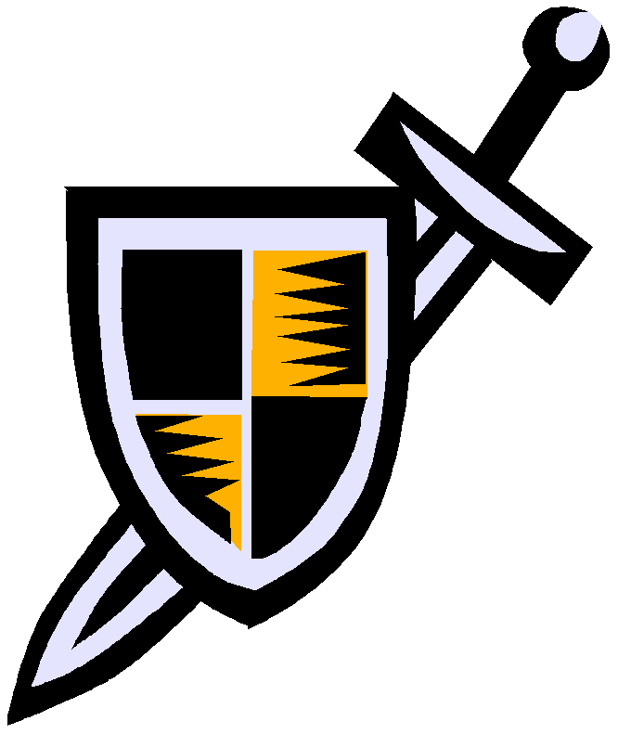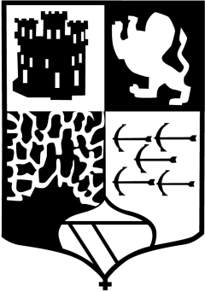Heraldic Colors
Yellow or Gold - Generosity
White / Silver - Peace & Sincerity Black - Constancy & Grif
Blue - Loyalty & Truthfulness
Red - Military Fortitude Green - Hope, Joy & Loyalty Purple - Sovereignty & Justice
Heraldic Animals
Bear - Protectiveness Bee - Industriousness Camel - Perseverance Dog - Loyalty
Dragon - Defender of Treasure Eagle - Leadership & Decisiveness Falcon or Hawk - Eagerness
Fox - Cleverness
Griffin (part eagle, part lion) - Bravery
Horse - Readiness to Serve
Lion - Courage
Pelican - Generosity & Devotion
Raven - Constancy
Snake - Ambition
Elk or Deer - Peace & Harmony
Personal Coat of Arms

What are some important places for you? What symbols represent these places? What are your favorite hobbies / activities? What symbols represent these activities? What is an animal that represents you? Why?
What else is important to you and should be represented in your Coat of Arms? What color best represents you?

Ideas for a Personal Motto

